REZEKNE ACADEMY OF TECHNOLOGIES
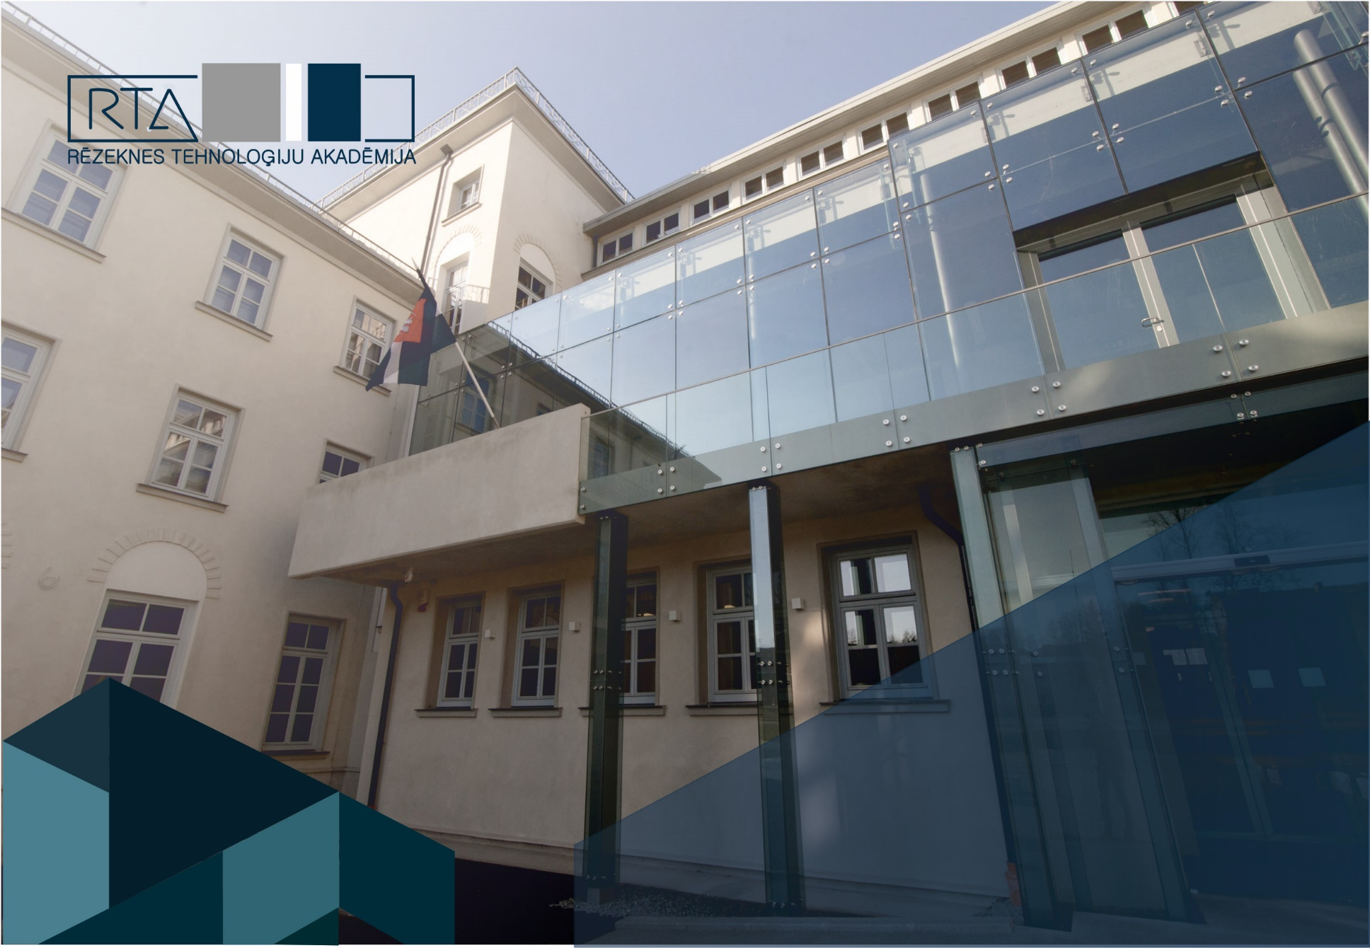

ECTS GUIDE AND COURSE CATALOGUE

2022/2023 AUTUMN SEMESTER
CONTENT

Application procedure for ERASMUS+ students 4

INTERNATIONAL OFFICE 5

FACULTY OF ECONOMICS AND MANAGEMENT 6

Study courses for BACHELOR study cycle 6

Business Administration, Management, Economics 6

Study courses for MASTER study cycle 7

Management Science 7

FACULTY OF ENGINEERING 7

Study courses for BACHELOR study cycle 7

Mechatronics 7

Engineer of programming 8

Study courses for MASTER study cycle 8

Computer Systems/ Information Systems Of Electronic Commerce 8

FACULTY OF EDUCATION, LANGUAGES, AND DESIGN 9

Study courses for bachelor study cycle 9

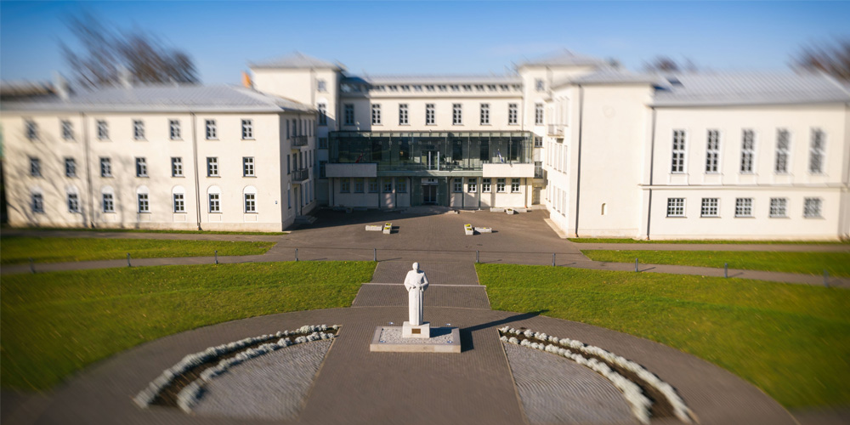
Rezekne Academy of Technologies is a state founded higher education and science institution of the Republic of Latvia which implements the study programs on bachelor, master, and PhD level.
Rezekne Academy of Technologies (http://www.rta.lv) has been involved in ERASMUS program since 1999. The institution has successful cooperation with universities and companies all over the EU countries and beyond.

Application procedure for ERASMUS+ students

The ECTS course catalogue is updated every semester. After receiving nomination from sending institution, the Letter of Invitation will be sent to the nominees (at request) or to the international office of the sending institution. Afterward, the nominee will have time to prepare requested document package:
- Application form
- Learning agreement
- Transcript of records
- Application for accommodation
- Passport or ID copy
- Health insurance

The document package should be complete. Learning Agreement has to be filled in, stamped and signed by the university and the student applying for the mobility.

The application document templates can be accessed on request. Completed documents should be sent electronically to the International office international@rta.lv.
When the document package will be evaluated and the learning agreement signed by the relevant program director, the nominee can be considered accepted by the host institution. The Letter of Acceptance at request will be sent to the student and/ or to the international office of the sending institution by the faculty coordinator. Do not hesitate asking any questions addressing them to international@rta.lv or to the coordinator of respective faculty.

Address of International Office of Rezekne Academy of Technologies
Rezeknes Tehnologiju Akademija
Atbrivosanas aleja 115,
Rezekne, LV-4604, Latvia
www.rta.lv, international@rta.lv

INTERNATIONAL OFFICE
 | Deputy rector for Cooperation and Development  ANDRIS SKROMULIS  Andris.Skromulis@rta.lv  Phone: +371- 22011199  Atbrīvošanas aleja 115, room 301 | 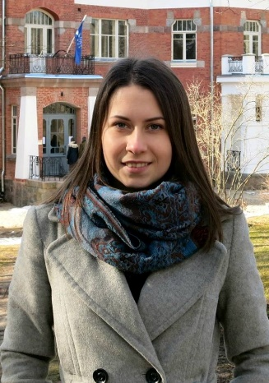 | Coordinator of Faculty of Engineering and Faculty of Education, Languages and Design  ILZE BODŽA  Ilze.Bodza@rta.lv  Phone: +371-28679395  Atbrīvošanas aleja 115, k4, room 211
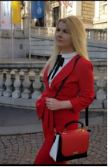 | Coordinator of Faculty of Economics and Management  Institutional Erasmus+ Coordinator  SANDA KAULIŅA  Sanda.Kaulina@rta.lv  Phone: +371-28390076  Atbrīvošanas aleja 115, k4, room 211

FACULTY OF ECONOMICS AND MANAGEMENT

Study courses for BACHELOR study cycle

Business Administration, Business Management, Economics

Code | Course Title | ECTS | Lecturer
Ekon2065 | Accounting | 6 | I.Mietule, Dr.oec., prof.
Ekon1017 | Basics Of Research Work | 3 | A.Puzule,Mg.oec., lect.
VadZ2053 | Business Communications | 3 | D.Znotiņa,Mg.soc.sc., lect.
Ekon3006 | Business Finance | 3 | I.Mietule, Dr.oec., prof.
VadZ4006 | Business Analysis | 3 | I.Kotāne, Mg.oec., lect.
VadZ3022 | Consumer Behavior | 3 | D.Znotiņa,Mg.soc.sc., lect.
VadZ3036 | E-commerce | 3 | I.Kotāne,Mg.oec., lect.
Ekon1083 | Entrepreneurship | 3 | Ē. Višķers, Mg.oec., lect.
Ekon1021 | European Economic Integration | 3 | L.Litavniece, Dr.oec., assoc.prof.
VadZ6041 | Finance Management | 6 | I.Mietule, Dr.oec., prof.
VadZ3090 | Human Resources Management | 3 | I.Arbidāne,Dr.oec., assoc.prof.
Ekon3101 | Insurance | 3 | J.Volkova, Mg.oec., lect.
Ekon4069 | Investments | 3 | J.Volkova, Mg.oec., lect.
Ekon3068 | International Marketing | 3 | I.Dembovska,Mg.oec., lect.
Ekon1084 | Marketing Management | 6 | I.Dembovska, Mg.oec., lect.
Ekon4050 | Marketing Research Methods | 3 | Ē. Viškers, Mg.oec., lect.
Ekon3065 | Marketing Communications | 3 | D.Znotiņa,Mg.soc.sc., lect.
Ekon1009 | Microeconomics | 6 | Ē. Višķers. Mg.oec., lect.
VadZ3058 | Organisational Behaviour and Leadership | 3 | I.Arbidāne,Dr.oec., assoc.prof.
Vadz3013 | Project Management | 3 | L.Amantova-Salmane,Mg.soc.sc., lect.
Vadz2018 | Principles of Management | 3 | A.Zvaigzne,Dr.oec., asoc.prof.
Ekon1028 | Public Finance | 6 | Ē.Žubule, Dr.oec., assoc.prof.
VadZ1034 | Records Management | 3 | Aija Čerpinska, Mg.soc.sc., lect.
Ekon1089 | Statistics | 3 | A.Klodāne, Mg.oec., lect.
Ekon3130 | Strategic Management | 6 | L.Amantova-Salmane,Mg.soc.sc., lect.
Ekon3014 | Tax System | 3 | A.Puzule,Mg.oec., lect.

Study courses for MASTER study cycle

Management Science
Code | Course Title | ECTS | Lecturer
Ekon6037 | Financial Management | 3 | I.Mietule, Dr.oec., prof.
VadZ6081 | Human Resources Management | 3 | I.Arbidāne, Dr.oec., prof.
Ekon6039 | International Economics | 3 | Ē.Žubule, Asoc.prof. Dr.oec.
Ekon5020 | Project Planning and Control | 3 | L.Amantova-Salmane, Mg.soc.sc., lekt.
Ekon6038 | Strategic Marketing Management | 3 | Daina Znotiņa, Mg.soc.sc., lekt.
VadZ6008 | Research Methods For Social Sciences | 6 | A.Puzule,Mg.oec., lect.
VadZ5002 | Competitiveness in Entrepreneurship | 3 | A.Zvaigzne,Dr.oec., asoc.prof.
VadZ7001 | Strategic Management | 6 | S.Ežmale, Dr.oec., doc.

FACULTY OF ENGINEERING

Study courses for BACHELOR study cycle

Mechatronics, Engineer of Programming
Code | Course Title | ECTS | Lecturer
Mate1009 | Calculus I | 4.5 | S.Kodors, Dr.sc.ing., assoc.prof.
Mate1009 | Calculus II | 4.5 | S.Kodors, Dr.sc.ing., assoc.prof.
Eteh3005 | Robotics | 4.5 | D.Kļaviņš, Mg.sc.ing., guest lect.
MašZ3039 | Robot Management Systems II | 3 | D.Kļaviņš, Mg.sc.ing., guest lect.
DatZ3021 | Introduction to Applications Programming | 3 | A.Zorins, Mg.sc.ing., lect.
MatZ1004 | Materials Science | 6 | Ē.Teirumnieka, Mg.che., lect.  G.Koļčs, Mg.comp., lect.
DatZ2012 | Computer Networks | 3 | M.Kijaško, Mg.sc.comp., lect.
DatZ3024 | Computer Architecture | 3 | P.Grabusts, Dr.sc.ing., prof.
ETel3001 | Microprocessors I | 1.5 | D.Kļaviņš, Mg.sc.ing., guest lect.
ETel3001 | Microprocessors II | 3 | D.Kļaviņš, Mg.sc.ing., guest lect.
Total |  | 36

Study courses for MASTER study cycle

Computer Systems/
Information Systems of Electronic Commerce

Code | Study course for MASTER study cycle | ECTS | Lecturer
DatZ6002 | Object-Oriented Programming and Integrated Development Environment | 3 | S.Kodors, Dr.sc.ing., assist.prof.
DatZ6001 | Requirements Engineering | 3 | A.Teilāns, Dr.sc.ing., prof.
DatZ6004 | Business Systems Analysis | 3 | A.Teilāns, Dr.sc.ing., prof.
DatZ6008 | Information Technology Standards | 3 | P.Grabusts, Dr.sc.ing., prof.
DatZ5019 | Semantics Technologies and Cloud Computing | 3 | A.Teilāns, Dr.sc.ing., prof.
DatZ6019 | Software Engineering | 3 | A.Teilāns, Dr.sc.ing., prof.
DatZ6011 | Data Protection | 3 | P.Grabusts, Dr.sc.ing., prof.
Total |  | 19

FACULTY OF EDUCATION, LANGUAGES, AND DESIGN

Study courses for bachelor study cycle

Elective courses
Code | Course Title | ECTS | Lecturer
Peda1120 | History of Education | 3 | G.Strods, Dr.paed., assoc.prof.
Peda4061 | Methodology of Teaching Music | 3 | J.Mežinskis, Mg.paed., guest lect.
MākZ1077 | The Field of Cultural Awareness and Self-expression in Art: Music I | 1.5 | J.Mežinskis, Mg.paed., guest lect.
Izgl2011 | Content and Learning approaches in the field of Health and Physical Activity | 3 | A.Kaupužs, Dr.paed., assist.prof.
Valo2179 | Cross-cultural Communication | 4.5 | G.Strods, Dr.paed., assoc.prof.
Peda2196 | Course Paper in Pedagogy and Methodology I | 3 | J.Dzerviniks, Dr.paed., prof.
Valo1339 | English Functional Communicative Grammar I | 6 | S.Iļjina, Mg.philol., lect
Valo1335 | Literature and Culture Studies of the English speaking countries for Teachers I | 3 | M.Opincāne, Dr.philol., assist.prof.
Valo1341 | Literature and Culture Studies of the English speaking countries for Teachers III | 3 | M.Opincāne, Dr.philol., assist.prof.
Valo1279 | Practical Grammar of English II | 3 | M.Opincāne, Dr.philol., assist.prof.
Valo1342 | Methodology of the English Functional Communication I | 3 | S.Iļjina, Mg.philol., lect
Valo2213 | Methodology of the English Language Aspects | 6 | M.Opincāne, Dr.philol., assist.prof.
Izgl1001 | Branch of Language Acquisition: English and Methodology II | 3 | M.Opincāne, Dr.philol., assist.prof.
Total |  | 45

Code | Course Title | ECTS | Lecturer
DziT4002 | WEB Page Design | 1.5 | E.Pavlovskis, Mg.sc.comp., guest lect.
Peda3235 | Health – Enhancing Physical Activity | 1.5 | A.Kaupužs, Dr.paed., assist.prof.
Psih1041 | Relationships of Environment and Personality | 3 | G.Strods, Dr.paed., assoc.prof.
MākZ1077 | Branch of Technologies: Design and Technologies I | 3 | A.Strode, Dr.paed., assoc.prof.
Valo1161 | Latvian language | 6 | A.Kļavinska, Dr. philol., prof.
Valo1276 | Oral Communication and Presentation in English I | 4.5 | S.Iļjina, Mg.philol., lect
MākZ2018 | Applied graphics and Font | 3 | Ilze Bodža, Mg. design., guest lect.
MākZ1043 | Drawing II | 3 | Natālija Brokāne Mg. design., guest lect.
Total |  | 25.5

